Build Smart on Kubernetes Learning Journey

Introduction to OpenShift Pipelines (Tekton)

Table of Contents

Getting Started 1

Introduction 1

Prerequisites 3

Setting up 3

Exercise 1 7

Learn about Tekton concepts 7

Exercise 2 9

Exercise 3 11

Create a project 11

## Getting Started

### Introduction

OpenShift Pipelines is a cloud-native, continuous integration and delivery (CI/CD) solution for building pipelines using [Tekton](https://tekton.dev/). Tekton is a flexible, Kubernetes-native, open-source CI/CD framework that enables automating deployments across multiple platforms (Kubernetes, serverless, VMs, etc) by abstracting away the underlying details.

OpenShift Pipelines features:

* Standard CI/CD pipeline definition based on Tekton
* Build images with Kubernetes tools such as S2I, Buildah, Buildpacks, Kaniko, etc
* Deploy applications to multiple platforms such as Kubernetes, serverless and VMs
* Easy to extend and integrate with existing tools
* Scale pipelines on-demand
* Portable across any Kubernetes platform
* Designed for microservices and decentralized teams
* Integrated with the OpenShift Developer Console

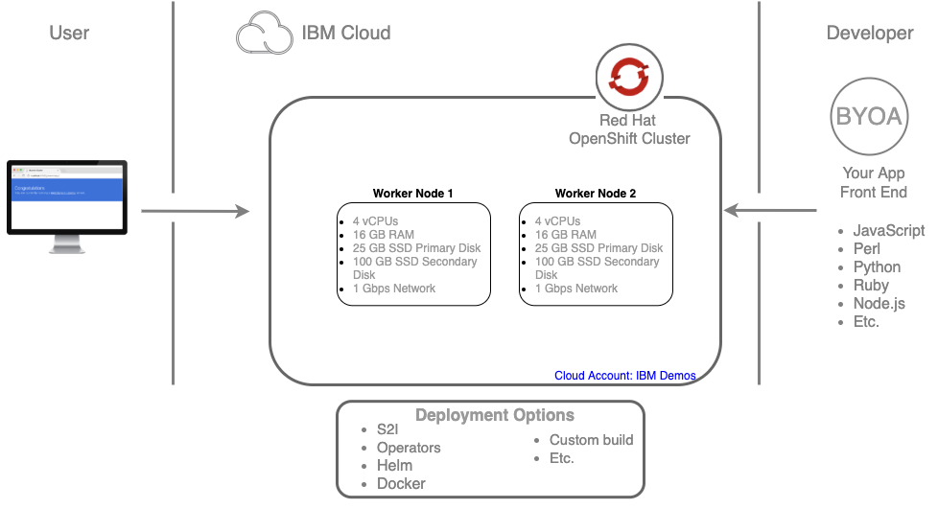

This tutorial walks you through pipeline concepts and how to create and run a simple pipeline for building and deploying a containerized app on OpenShift, and in this tutorial, we will use Triggers to handle a real GitHub webhook request to kickoff a PipelineRun.

In this lab you will:

* Learn about Tekton concepts
* Install OpenShift Pipelines
* Deploy a Sample Application
* Install Tasks
* Create a Pipeline
* Trigger a Pipeline

### Prerequisites

You will need the following to complete the exercises in this lab:

* An IBM Cloud user ID to access an OpenShift 4 cluster.
* You will also use the Tekton CLI (tkn).

### Setting up

**Note:** The sample output shown in the lab guide may be slightly different than what you see in the output when you issue the commands for your cluster.

**Access the OpenShift web console**

1. Launch the IBM Cloud portal: <https://cloud.ibm.com> and ensure the xxxxxx – Advowork account is selected. Navigate to the Clusters and open the cluster for the the lab.

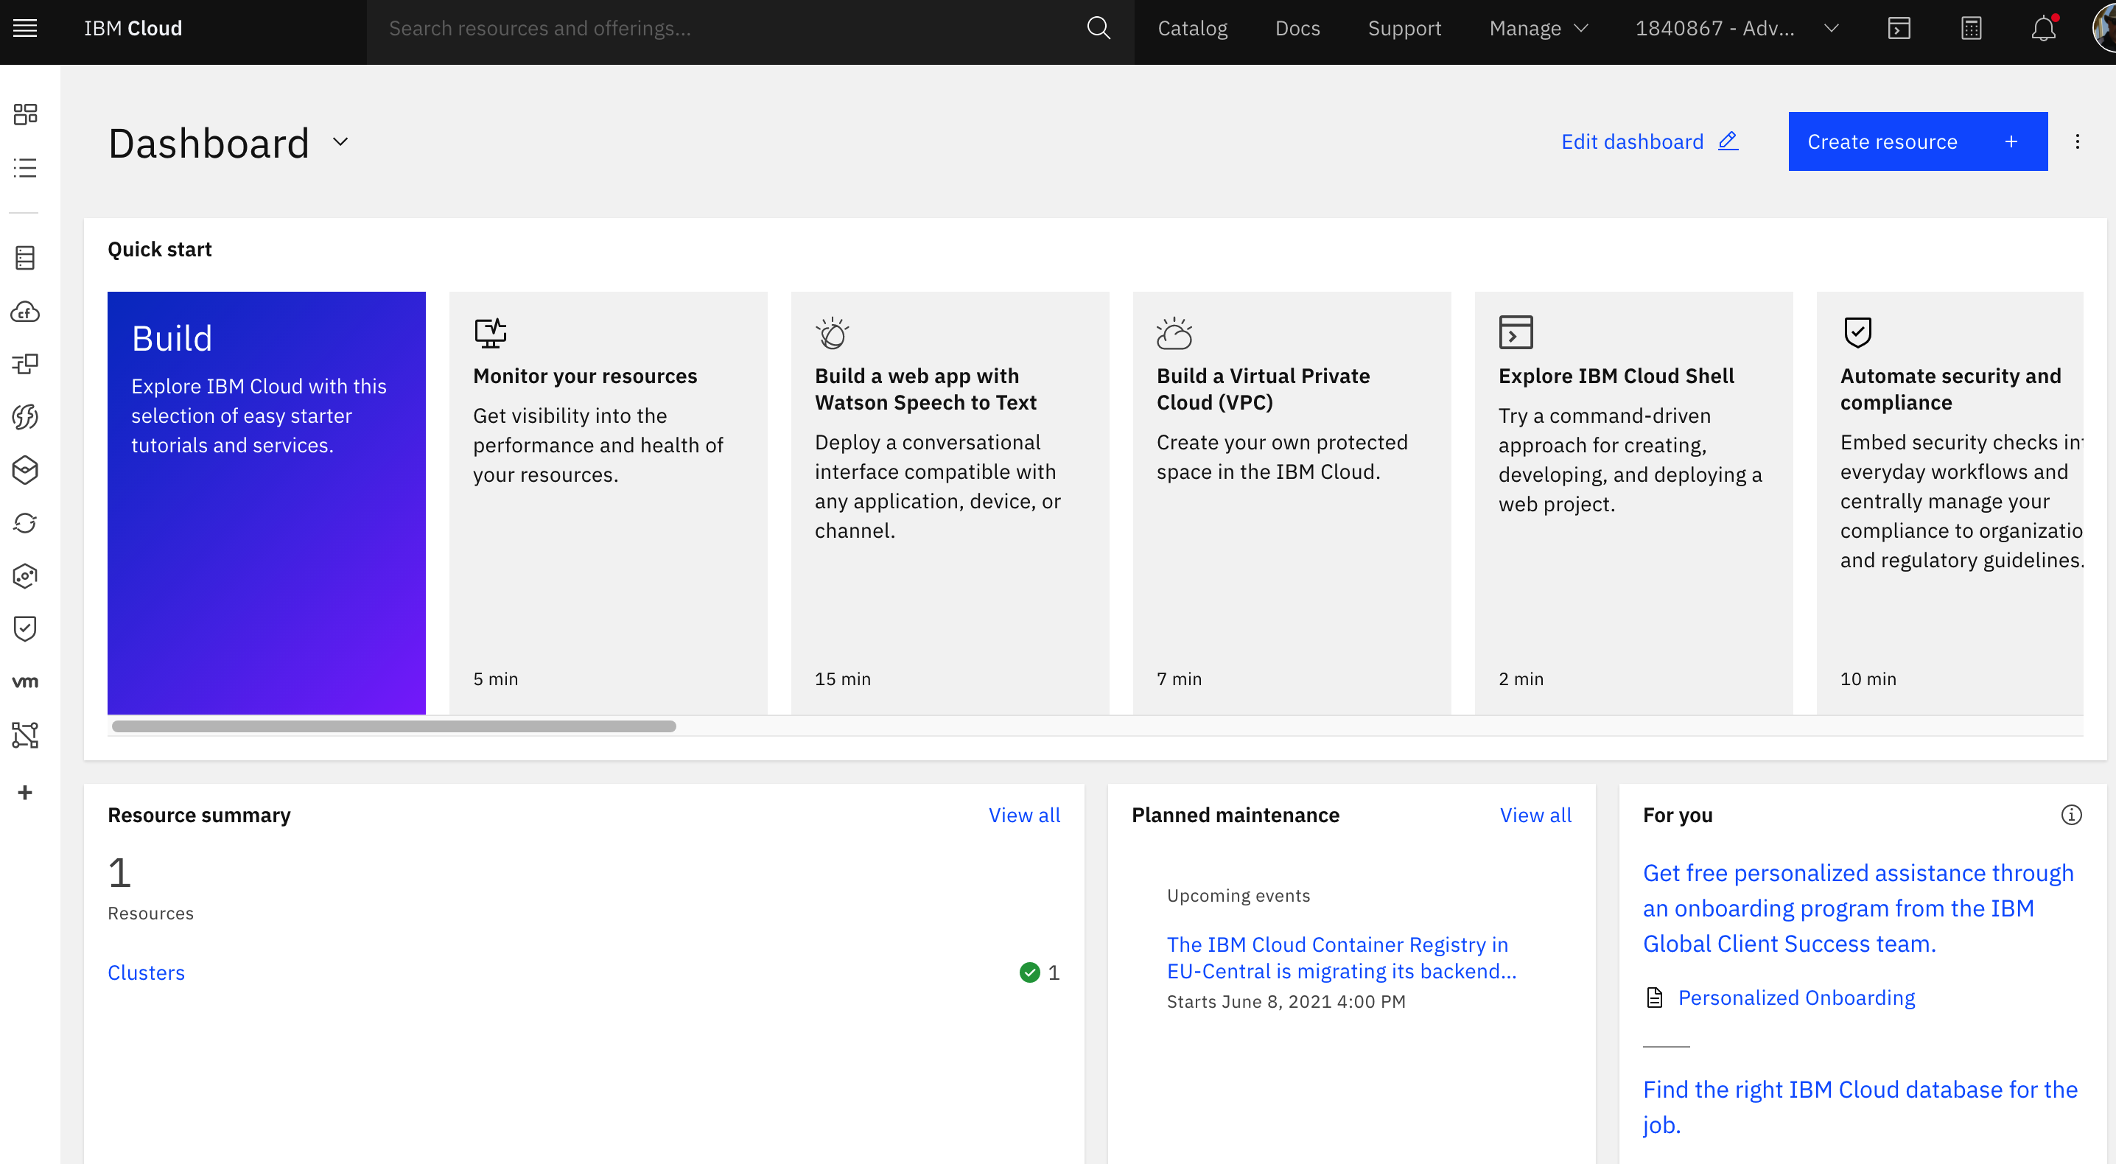



1. **Note:** The IBM Cloud Portal and OpenShift web console will be opened in a new browser tab. You need to switch between this tab and the new tabs to accomplish many of the lab tasks. You may want to open the new tabs in new windows and display both browser windows at the same time. You may need to disable pop-up blockers if you do not see the new tabs.



1. On the IBM Cloud portal page, notice details about the OpenShift cluster that has been provisioned, including:

* Number of Worker Nodes and their status (you should see two worker nodes in a “normal” state)
* Links to manage worker nodes and worker pools
* Link to open the “OpenShift web console”

**Note**: In this lab environment, your IBM Cloud User ID has been given limited permissions in an IBM Advowork account. While you can explore these options in the IBM Cloud portal, you will not be able to add, remove, or modify worker nodes or pools. To learn more about these processes, check out the videos and product tours here: Red Hat OpenShift on IBM Cloud Demos.

1. Next, explore the **OpenShift web console**.



1. In the OpenShift web console, notice the following:

* The different perspectives available in the OpenShift web console: Administrator and Developer
* Capabilities of each perspective and dashboards available for each

1. Take a few minutes to explore the OpenShift web console. Try finding the following:

* Number of nodes in the cluster inventory dashboard
* Standard services deployed in the default project
* Operators installed

You need a cloudshell you can use <https://shell.cloud.ibm.com/>. It should be attached to the IBMid, that you created for the workshop.

As well, to connect the cloudshell to your OpenShift cluster:

- Browse to the OpenShift web console.

- From the dropdown menu in the upper right of the page, click "Copy Login" Command.

- Click the "Display Token" link.

- Copy the "Log in with this token" command line.

- Paste the copied command in your terminal.

- Browse to the oauth token request page and follow the instructions on the page.

Sample command:

oc login --server https://c109-e.us-east.containers.cloud.ibm.com:31411 -u apikey -p 75ecc28297050904b4fedac2be174595

Testing your environment

1. Validate access to your cluster by viewing the nodes in the cluster:

oc get node

Sample Output:

NAME STATUS ROLES AGE VERSION

* + - 1. Ready master,worker 37h v1.16.2

1. Execute the command below to view services, deployments, and pods:

oc get svc,deploy,po --all-namespaces

Sample Output:

NAME STATUS ROLES AGE VERSION

10.171.76.77 Ready master,worker 37h v1.16.2

container-lab$ oc get svc,deploy,po --all-namespaces

NAMESPACE NAME TYPE CLUSTER-IP EXTERNAL-IP PORT(S) AGE

calico-system service/calico-typha ClusterIP 172.21.108.58 <none> 5473/TCP 37h

default service/kubernetes ClusterIP 172.21.0.1 <none> 443/TCP 38h

default service/openshift ExternalName <none> kubernetes.default.svc.cluster.local <none> 37h

default service/openshift-apiserver ClusterIP 172.21.146.181 <none>

...

**Note:** Some commands have large amounts of data in their output. You can scroll up and down in the terminal window and clear it using the **clear** command.

1. Execute the command below to clear the terminal screen:

clear

1. Execute the command below to view all OpenShift projects:

oc get projects

Sample Output:

NAME DISPLAY NAME STATUS

calico-system Active

default Active

example-health Example Health Project Active

ibm-cert-store Active

ibm-system Active

kube-node-lease Active

kube-public Active

kube-system Active

openshift Active

openshift-apiserver Active

openshift-apiserver-operator Active

...

**End Setting up** ___

## Exercise 1

### Learn about Tekton concepts

**Exercise 1**

**Learn about Tekton concepts**

Tekton defines a number of [Kubernetes custom resources](https://kubernetes.io/docs/concepts/extend-kubernetes/api-extension/custom-resources/) as building blocks in order to standardize pipeline concepts and provide a terminology that is consistent across CI/CD solutions. These custom resources are an extension of the Kubernetes API that let users create and interact with these objects using kubectl and other Kubernetes tools.

The custom resources needed to define a pipeline are listed below:

* Task: a reusable, loosely coupled number of steps that perform a specific task (e.g. building a container image)
* Pipeline: the definition of the pipeline and the Tasks that it should perform
* TaskRun: the execution and result of running an instance of task
* PipelineRun: the execution and result of running an instance of pipeline, which includes a number of TaskRuns

In short, in order to create a pipeline, one does the following:

* Create custom or install [existing](https://github.com/tektoncd/catalog) reusable Tasks
* Create a Pipeline and PipelineResources to define your application's delivery pipeline
* Create a PersistentVolumeClaim to provide the volume/filesystem for pipeline execution
* Create a PipelineRun to instantiate and invoke the pipeline

For further details on pipeline concepts, refer to the [Tekton documentation](https://github.com/tektoncd/pipeline/tree/master/docs" \l "learn-more) that provides an excellent guide for understanding various parameters and attributes available for defining pipelines.

The Tekton API enables functionality to be separated from configuration (e.g. [Pipelines](https://github.com/tektoncd/pipeline/blob/master/docs/pipelines.md) vs [PipelineRuns](https://github.com/tektoncd/pipeline/blob/master/docs/pipelineruns.md)) such that steps can be reusable.

Triggers extends the Tekton architecture with the following CRDs:

* [TriggerTemplate](https://github.com/tektoncd/triggers/blob/master/docs/triggertemplates.md) - Templates resources to be created (e.g. Create PipelineResources and PipelineRun that uses them)
* [TriggerBinding](https://github.com/tektoncd/triggers/blob/master/docs/triggerbindings.md) - Validates events and extracts payload fields
* [EventListener](https://github.com/tektoncd/triggers/blob/master/docs/eventlisteners.md) - Connects TriggerBindings and TriggerTemplates into an [addressable](https://github.com/knative/eventing/blob/master/docs/spec/interfaces.md) endpoint (the event sink). It uses the extracted event parameters from each TriggerBinding (and any supplied static parameters) to create the resources specified in the corresponding TriggerTemplate. It also optionally allows an external service to pre-process the event payload via the interceptor field.
* [ClusterTriggerBinding](https://github.com/tektoncd/triggers/blob/master/docs/clustertriggerbindings.md) - A cluster-scoped TriggerBinding

Using tektoncd/triggers in conjunction with tektoncd/pipeline enables you to easily create full-fledged CI/CD systems where the execution is defined **entirely** through Kubernetes resources.

You can learn more about triggers by checking out the [docs](https://github.com/tektoncd/triggers/blob/master/docs/README.md)

In the following sections, you will go through each of the above steps to define and invoke a pipeline.

**End Exercise 1**

## Exercise 2

**Install OpenShift Pipelines**

**Exercise 2**

**Install OpenShift Pipelines**

OpenShift Pipelines is provided as an add-on on top of OpenShift that can be installed via an operator available in the OpenShift OperatorHub.

To start, make sure you are on the **Administrator** perspective as shown below:

Go to **Operators > OperatorHub** in the Web Console. You can see the list of available operators for OpenShift provided by Red Hat as well as a community of partners and open-source projects.

In the search bar where it says Filter by keyword..., type OpenShift Pipelines to find the **OpenShift Pipelines Operator**:

Click on **OpenShift Pipelines Operator**, **Continue**, and then **Install**:

Leave the default settings and click on **Install** in order to install the Operator:

After clicking **Install**, you will be taken to the **Installed Operators** page. If you do not see the **OpenShift Pipelines Operator** as shown below, simply wait a moment while the **OpenShift Pipelines Operator** finishes installation:

That's all. The operator now installs OpenShift Pipelines on the cluster.

You can confirm the following by checking tekton-pipelines and tekton-triggers pods with Running state in openshift-pipelines namespace. If so, openshift-pielines have been installed on your cluster.

**End Exercise 2** ___

## Exercise 3

### Create a project

**Exercise 3**

**Create a project**

You need a cloudshell you can use <https://shell.cloud.ibm.com/>. It should be attached to the IBMid, that you created for the workshop.

Create a project for the sample application that you will be using in this tutorial:

oc new-project pipelines-tutorial

OpenShift Pipelines automatically adds and configures a ServiceAccount named pipeline that has sufficient permissions to build and push an image. This service account will be used later in the tutorial.

Run the following command to see the pipeline service account:

oc get serviceaccount pipeline

You will use the simple application during this tutorial, which has a [frontend](https://github.com/openshift-pipelines/vote-ui) and [backend](https://github.com/openshift-pipelines/vote-api)

You can also deploy the same applications by applying the artifacts available in k8s directory of the respective repo

If you deploy the application directly, you should be able to see the deployment in the OpenShift Web Console by switching over to the **Developer** perspective of the OpenShift Web Console. Change from **Administrator** to **Developer** from the drop down as shown below:

Make sure you are on the pipelines-tutorial project by selecting it from the **Project** dropdown menu. Either search for pipelines-tutorial in the search bar or scroll down until you find pipelines-tutorial and click on the name of your project.

**End Exercise 3** ___